**CRYSTAL GROWTH METHODS AND THEIR LIMITATIONS**

**THE CONVENTIONAL METHOD**

While Gallium Nitride (GaN) is extremely promising, there are some aspects that present a challenge to its integration into use in the commercial market. The main issue stems from issues with the growth of the GaN crystals. The conventional way to manufacture semiconductor substrates is known as the Czochralski process [e]. To begin this process, “you begin with a tiny, high-quality crystal to seed the growth process” [e]. Then, this seed crystal is rotated inside the liquid of that same material [e]. The seed crystal is then extracted, and the molten liquid is allowed to cool [e]. This forms what is known as the boule which is then sliced into wafers to provide the semiconductor’s substrate [e]. However, this method does not work with GaN. Liquid GaN is very hard to obtain. As seen in figure A, under moderate pressure GaN melts into Ga metal and N2 gas [a]. However, Ga metal and N2 is not what is required, liquid GaN must be produced to produce a GaN crystal. Only after the pressure reaches >4.5 GPa and the temperature reaches around 2500°C have GaN crystals been produced [a]. To provide some perspective, 4.5 GPa is around 40,000 times atmospheric pressure. These conditions are extremely expensive to obtain and maintain [e]. Also, the size of these crystals has only been around “100 µm” and thus are not suitable for production [a]. Therefore, alternative methods must be used to grow suitable GaN crystals. Two of the methods which are most popular are the Halide Hydride Vapor Phase Epitaxy (HVPE) and the ammonothermal growth method [b]. However, both methods have distinct benefits and detriments to their processes which will be explored in their respective sections.

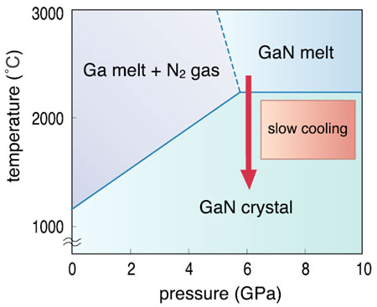

Figure (aa) from <http://jolisfukyu.tokai-sc.jaea.go.jp/fukyu/tayu/ACT04E/05/0505.htm> shows the phase diagram of GaN

**HVPE GROWTH OF GALLIUM NITRIDE**

In today’s market, HVPE is the most common process to grow GaN crystals [b]. The basis of the HVPE system is crystallization of GaN from the gaseous phase [b]. First, Ga is reacted with hydrochloride to form gallium chloride (GaCl) [b]. Then, “GaCl is transported by the carrier gas (N2, H2, Ar, He, or their mixtures) to the high-temperature zone” [b]. In this high-temperature zone, the GaCl “reacts with ammonia to form GaN” [b]. The heat of this zone is around 1000°C to 1100°C [b]. The GaN is then crystalized on a “native or foreign substrate (mainly MOCVD-GaN/ sapphire template or GaS)” [b]. The main advantage of the HVPE process is high growth [b]. Growth rates for the GaN grown by the HVPE system can reaches rates upwards of 1800 µm per hour [b]. Compared to the growth rates of the conventional method and the ammonothermal method this is extremely fast. The two main downfalls of the HVPE are scalability and issues between GaN and a foreign substrate [e]. The maximum number of crystals that can be produced by the HVPE method is less than 10 crystals [b]. This is a problem as the need is for bulk production of GaN crystals. The other issue deals with the mismatch between GaN and a foreign substrate. The crystallization of GaN on a foreign substance leads to mismatches between the crystalline structures of the GaN and the sapphire. Specifically, this leads to a “bowing of crystallographic planes” which is a result of the “large differences between the lattice constants and thermal expansion coefficients of the foreign substrate and the nitride layer” [b]. However, sapphire isn’t the only substrate being researched. Most of the research is being conducted into growing the GaN crystals on a native GaN substrate [c]. This would reduce the imperfections drastically. To provide some perspective, “GaN grown on GaN can have as few as 100 to 1000 defects per cm2 in the crystal” [c]. While this seems like a large number of defects, these defects are as impactful as it would be on another semiconductor material [c]. The reason for this is still under debate, but the consensus is that defects are not the main issue. It is speculated that one of these GaN-GaN chips could replace ten of the sapphire-GaN chips. Thus, to improve this process it is necessary that high quality GaN crystals be produced for use in the substrate of the HVPE method. A potential solution to this need would be to grow the GaN substrate crystals through a process known as ammonothermal growth.

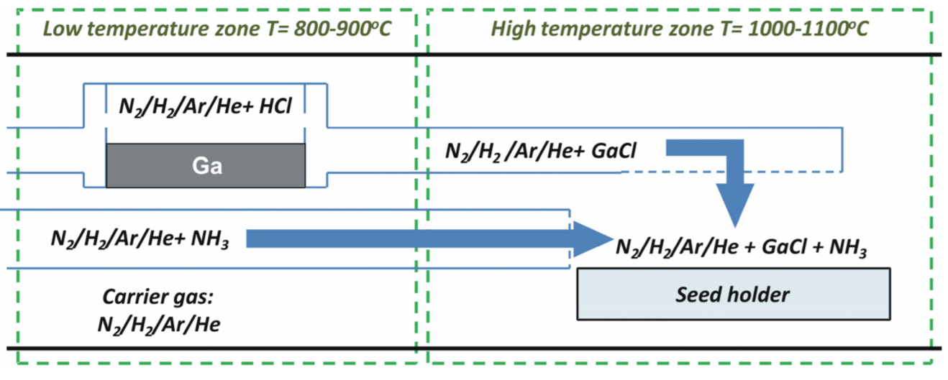

Figure (cc) shows the HVPE reactor

**AMMONOTHERMAL GROWTH OF GALLIUM NITRIDE CRYSTALS**

While the HVPE method of growth focused on crystallization of GaN from the gaseous stage, the ammonothermal method focuses on growing GaN crystals from the solution phase. The general set-up is shown in figure 3 seen below. The apparatus that the reaction is contained in is called the autoclave [d]. First, the GaN is dissolved in an ammonia solution with the use of a basic mineralizer [d]. This is necessary as GaN is highly insoluble in pure NH3 [d]. The mineralizer can be either acidic or basic, but usually the basic mineralizer is used as the acidic mineralizers require the autoclave be coated noble-metal (platinum) to prevent corrosion of the autoclave [d]. One of the most come mineralizers is potassium amide [d]. The reactions that model this will be shown below in figure 4. The temperature and pressure of this reaction can vary but are usually in the range of “475-525°C” and “150 MPa” respectively [d]. The two regions of the autoclave are separated by the baffle which ensures the temperature difference and a constant circulation of the NH3 [d]. The temperature and pressure of the second region are changed from the first region of the autoclave and usually range between “400-600°C and .1-.3 GPa” [a]. One of the interesting qualities of GaN is its solubility [e]. In general, “warm solvents can dissolve more material than colder ones” [e]. However, GaN is what is known as retrograde soluble which means that the solubility decreases as temperature increase. This is why the temperature of the second zone of the autoclave increases. Under these conditions the “GaN recrystallizes from those soluble intermediates onto GaN seeds in the crystallization zone” [a]. The main advantages of the ammonothermal growth method is the capability to mass produce GaN crystals and “excellent scalability with the size of the autoclave” [a]. Ammonothermic growth does have its downsides. Specifically, the growth rate is very low compared to that of the HVPE method [b]. While there are cons to this method, the pros are well worth exploring this method. There are a few companies exploring this method with the company Ammono being first among them. Ammono is a pioneer in the ammonothermal growth of GaN with their lead scientists and founders developing the methods that are used today. Ammono’s crystal sizes have reached upwards of 2 inches but their prices are still quite high [e]. However, Ammono claims that their prices should fall in the long run and become comparable to gallium arsenide [e]. One of the issues with the HVPE method of crystal growth was lack of scalability. Ammono’s process pushes ammonothermal growth ahead in this regard. It has been documented that their autoclaves can produce upwards of 70 2-inch crystals of GaN per each run. However, the one major downside to ammonothermic growth is the growth rate. The ammonothermic growth rate is around ten times slower than the HVPE method but this can be combatted with the number of crystals that can be grown at a time. While the HVPE and ammonothermic growth methods are often pitted against each other, there is research being done into combining the two to help remediate the others downsides.

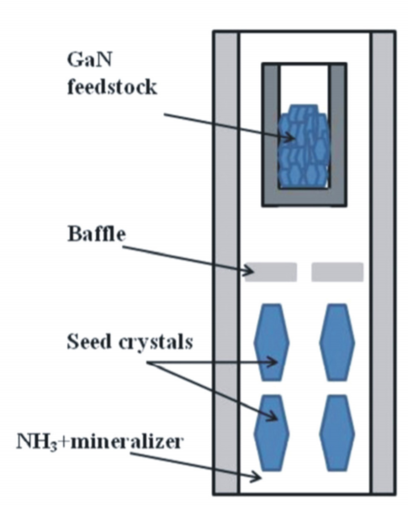 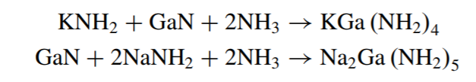

Figure (cc) shows the basic HVPE reactor. Figure (dd) shows the reactions for ammonothermal growth

**COMBINING THE HVPE AND AMMONOTHERMIC GROWTH METHODS**

There is potential to combine the HVPE and ammonothermic growth methods into one system. Specifically, using the ammonothermically grown crystal as a seed crystal for the HVPE method [b]. As seen in the table below, the methods’ cons are usually the other methods’ pros. Specifically, this solves the issue of lattice mismatch between the GaN crystals grown on a foreign substrate. The incorporation of Ammono’s crystals as the HVPE seed crystal solves this issue. As seen in the table below, the structural quality of the GaN grown via the HVPE method increases in quality when grown on a native seed. However, these seed crystals must be grown through the ammonothermal method as crystals of high structural quality are needed [b]. This is a nice way to pair the two growth methods and offers another potential solution to the need for bulk GaN. Both methods have their own respective strengths and weaknesses. In order for GaN to become less expensive, both methods need to become more refined. This process of combination is only a glimpse of what is possible when the two are combined and methods like this should be explored further.

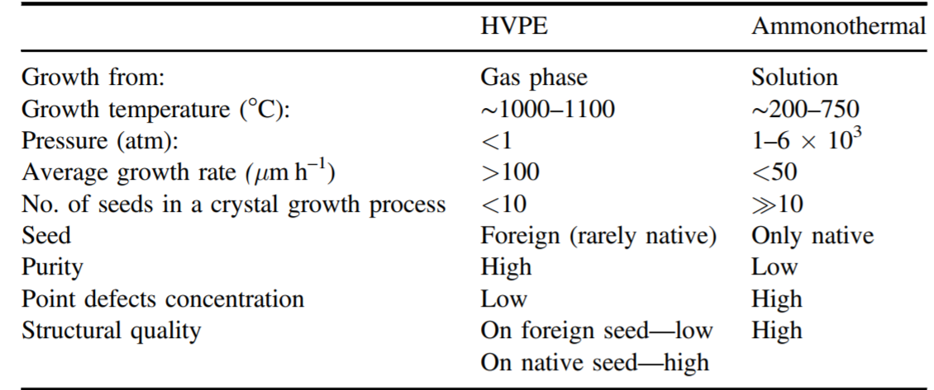

Figure dd shows the differences between the HVPE and ammonothermal methods

**OUTLOOK FOR GALLIUM NITRIDE**

With silicon-based transistors reaching their theoretical limit in terms of their size, it is imperative to come up with a solution for the need of more computing power. New semi conductive materials must be found to solve this need. Gallium Nitride is by no means the only solution, but it is a viable alternative to silicon. GaN’s performance as a wide band gap transistor is far superior to that of silicon . However, the cost to produce GaN crystals of suitable quality hampers its use in the market place. As seen in figure D, GaN is by far the most expensive substrate to produce. However, the relationship between cost and the amount produced is negative. Meaning that as the amount of GaN substrates is increased the price should go down. Thus, this is promising with such companies as Ammono working to produce bulk high quality GaN crystals. Also, the combination of the HVPE and ammonothermal methods will help facilitate the production of more GaN. By no means is GaN perfect and the only semiconductor material that should be researched. Nevertheless, GaN does have many niche areas where it would be an added improvement on the existing processes. Thus, if the price of GaN does decrease to a more reasonable level and the quality of the GaN crystals grown continue to increase, it would be feasible to assume that GaN would be integrated into the market at some point in our lifetime. As the EPC’s CEO, Alex Lidow, states “The area efficiency of current GaN transistors is more than 500 times lower than theoretically possible. It should therefore be expected that die sizes will continue to shrink, while performance increases and costs go down at each step” [f]. Further cementing the idea that GaN is a viable technology and will continue to be developed and researched.

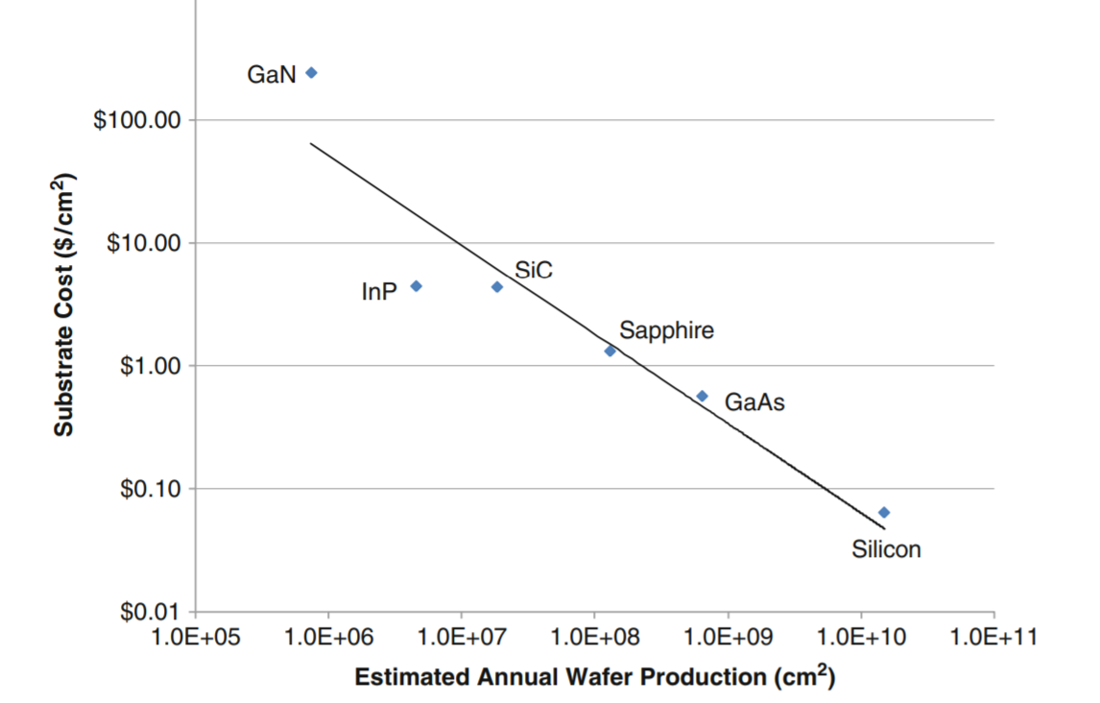

Figure ee shows the relationship between cost of the substrate vs how many are actually produced

Sources

[a] D. Ehrentraut, E. Meissner, and M. Bockowski. “Technology of Gallium Nitride Crystal Growth.” Springer Series In Material Science. Published 2010. Accessed 02.25.2018. https://link.springer.com/content/pdf/10.1007%2F978-3-642-04830-2.pdf

[b] M. Bockowski, M. Iwinska, M. Amilusik, M. Fijalkowski, B. Lucznik and T. Sochacki. “Challenges and future perspectives in HVPEGaN growth on ammonothermal GaN seeds.” Iopscience. Published 08.05.2016. Accessed 02.20.2018. http://iopscience.iop.org/article/10.1088/0268-1242/31/9/093002/pdf

[c] “Gallium Nitride: The Material that Made the Difference.” University of California – Santa Barbara College of Engineering. Published 12.15.2017. Accessed 02.09.2018. <https://engineering.ucsb.edu/news/gallium-nitride-material-made-difference>

[e] R. Stevenson. “The World’s Best Gallium Nitride: A little Polish company you’ve never heard of is beating the tech titans in a key technology of the 21st century.” IEEE Spectrum. Published 06.30.2010. Accessed 02.09.2018. <https://spectrum.ieee.org/semiconductors/materials/the-worlds-best-gallium-nitride>

[f] A. Lidow. “GaN-on-Silicon Power Devices: How to Dislodge Silicon-Based Power MOSFETs.” Institute of Electrical and Electronics Engineers (IEEE) Power Electronics Magazine. Published 03.07.2017. Accessed 02.09.2017.

## Figure aa “Single Crystal Growth of GaN at High Pressure.” Japan Atomic Energy Research Institute. Published 2004. Accessed 02.25.2018. http://jolisfukyu.tokai-sc.jaea.go.jp/fukyu/tayu/ACT04E/05/0505.htm

Figure bb M. Bockowski, M. Iwinska, M. Amilusik, M. Fijalkowski, B. Lucznik and T. Sochacki. “Challenges and future perspectives in HVPEGaN growth on ammonothermal GaN seeds.” Iopscience. Published 08.05.2016. Accessed 02.20.2018. http://iopscience.iop.org/article/10.1088/0268-1242/31/9/093002/pdf

Figure cc M. Bockowski, M. Iwinska, M. Amilusik, M. Fijalkowski, B. Lucznik and T. Sochacki. “Challenges and future perspectives in HVPEGaN growth on ammonothermal GaN seeds.” Iopscience. Published 08.05.2016. Accessed 02.20.2018. http://iopscience.iop.org/article/10.1088/0268-1242/31/9/093002/pdf

Figure dd M. Bockowski, M. Iwinska, M. Amilusik, M. Fijalkowski, B. Lucznik and T. Sochacki. “Challenges and future perspectives in HVPEGaN growth on ammonothermal GaN seeds.” Iopscience. Published 08.05.2016. Accessed 02.20.2018. http://iopscience.iop.org/article/10.1088/0268-1242/31/9/093002/pdf

Figure ee D. Ehrentraut, E. Meissner, and M. Bockowski. “Technology of Gallium Nitride Crystal Growth.” Springer Series In Material Science. Published 2010. Accessed 02.25.2018. https://link.springer.com/content/pdf/10.1007%2F978-3-642-04830-2.pdf